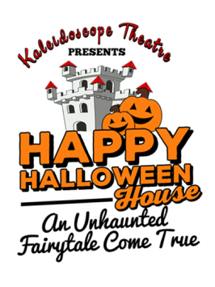
Ticket order form for Kaleidoscope Theatre’s
Happy Halloween House
Complete this form and mail with a check made out to Kaleidoscope Theatre for the total amount. Mail the check and this form no later than one week before the event to the address below. A ticket voucher will be mailed to you.
October 19, 20
1:00 to 5:00 pm
Scottish Rite Auditorium, Cranston
Marianne Douglas/Box Office Manager
PO Box 356
Barrington, RI 02806
Please supply your mailing information here:
Name ___________________________________________________________
Street ___________________________________________________________
Town/City _________________________________ State ____ Zip __________
Email address: ____________________________________________________
Phone number: _____________________________________
Fill out the table below. Use the $10 price if you need less than 5 tickets. Use the $8 price if you are planning to bring 5 or more people.
You may use the tickets on either day anytime up to ½ hour before closing time.
Number of Tickets | Cost per ticket | Total
 | $10.00
 | $8.00
 | SUBTOTAL
 | Plus shipping | $1.00
 | TOTAL

